Topic: Ecology | Name: Date:
Biotic Factors  Abiotic Factors  Habitat  Niche  Competitive Exclusion Principle  Predation  Symbosis  Primary  Secondary  Climax Community | - Type of food organism eats  - How it gets food  - Which other species eats the organism  - When and how the organism reproduce  - Cape May Warbler feeds at the tips of branches near the top of the spruce tree  - Bay-Breasted Warbler feeds in the middle part of the spruce tree  - Yellow Rumped Warbler feeds in the lower part of the tree and at the bases of the middle branches  Ecological Succession  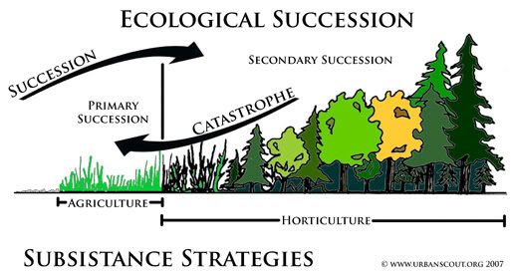  - 1st species to populate  - Often lichens (fungus and algae)  When they die they create organic material to make soil for other plants to grow  - Plants start to grow
Reflection/Summary:

Questions you may still have regarding the material learned:  1.  2.  3. | Answers :

