Topic: Miller-Urey | Name: Date:
- 1953 Stanley L. Miller and Harold C. Urey
- University of Chicago

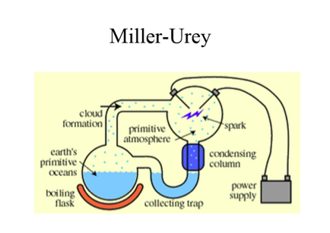

- Put together chemicals they thought would be in the Earth’s environment
1.
2.
3.
4.

- Then they ran electricity through the system for a week which simulated
______________________________________

Results:

Reflection/Summary:

Questions you may still have regarding the material learned:  1.  2.  3.  4. | Answers :

